**Predicting Bankruptcy**

**Data Preparation:**

* Data Pre-Analysis
* Data Pre-Processing
* Data Post-Analysis

**Data Pre-Analysis**

* For each of the following 66 failed firms, a healthy firm of about the same size was selected, this was measured by the book value of the firm’s assets. The study was conducted to show how well one can predict bankruptcy two years in advance. Below labels are shown to describe the meaning of the data included.

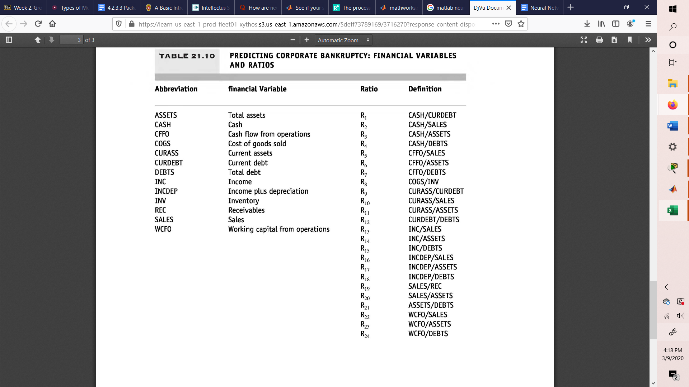

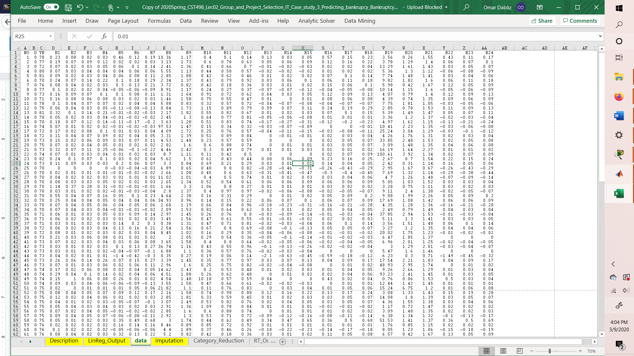

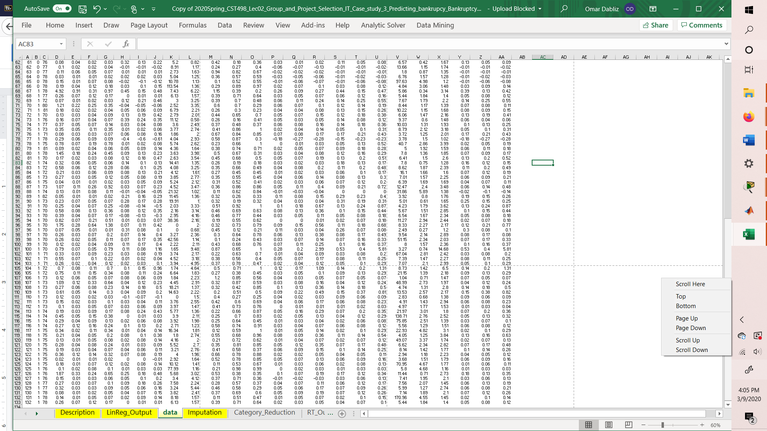

The Neural network was analyzed using all the data as Inputs, and 0-1 as the target data, below the trained data is shown.

